# Project Abstract:

## Problem Statement:

The problem under consideration is basically a classification problem. The idea of this project is to classify the tweets on the basis of happy or sad. The dataset for this problem will be holding random tweets along with some tags. Also, the same project can be hold for business reviews etc.

## Motivation:

The motivation behind it was since the online business these days growing a lot so it will be better if we make a model that can tell us about positive and negative ratio of reviews on our business sites. It will help them to improve that part of business where they didn’t get positive ratings. Since, this project main focus is on tweets so we can get the idea of people using tweets that what sentiments they were going through while tweeting.

## Methodology:

To implement the solution to this problem we will first build a dataset and then train a machine model to classify. To build the dataset we can collect the data from the user using google forms or we can collect the dataset from available sources from the web. In this case the dataset was filled manually until that. Once the dataset was ready, we then chose the decision tree algorithm to classify.

# Project Summary:

A great number of tweets or reviews can be found around the world, each of which has various types. The factors that determine the type of tweets/reviews are writer writing behavior and words or some tags. Determining the variety of comments or reviews individually by looking at them, which is time-consuming task and requires great effort? The aim of this study is to classify the types of comments/tweets that could be positive/happy or negative/sad by using different machine learning methods and techniques.

Following are the Classifier and techniques applied to Evaluate Performance:

* NLTK Technique
* DT (Decision Tree Classifier)
* TFIDF Features

# Detailed Description of the Project:

## Methodology:

This program is made on the principle of supervised machine learning. The development of this program is divided into the following phases:

* Problem analysis
* Researching Resources and gathering data
* Training and evaluating the model
* Integrating the trained model to a GUI app.

# Results:

Following are the results after the training and evaluation of the model using Decision Tree and TFIDF.

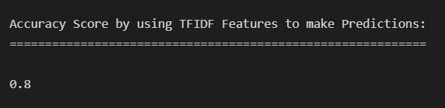

# Screenshots:

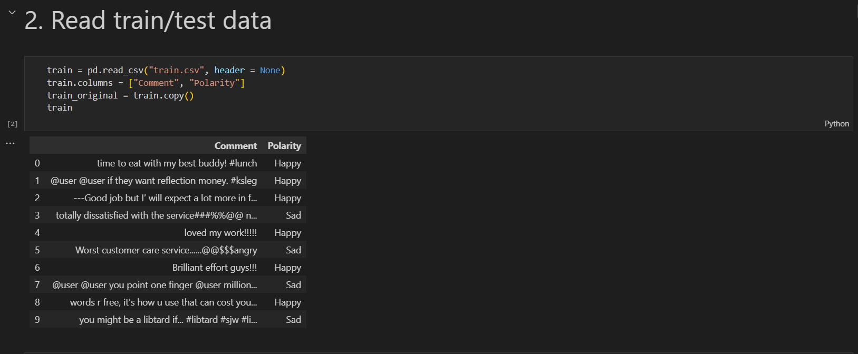

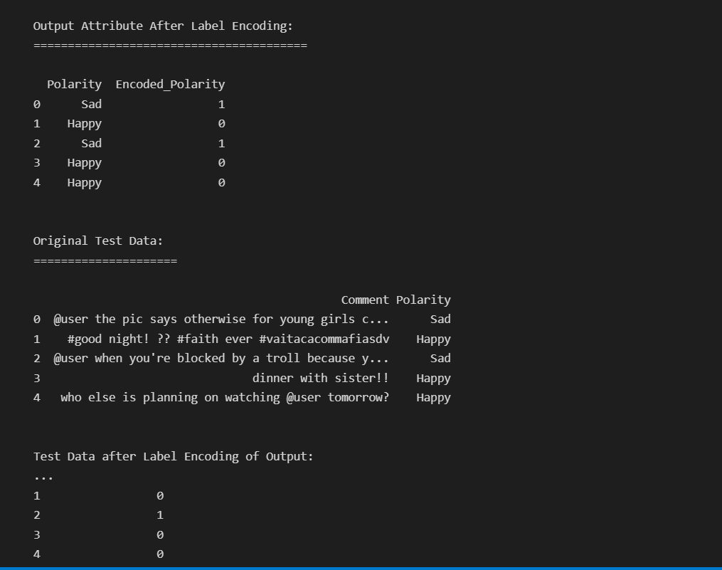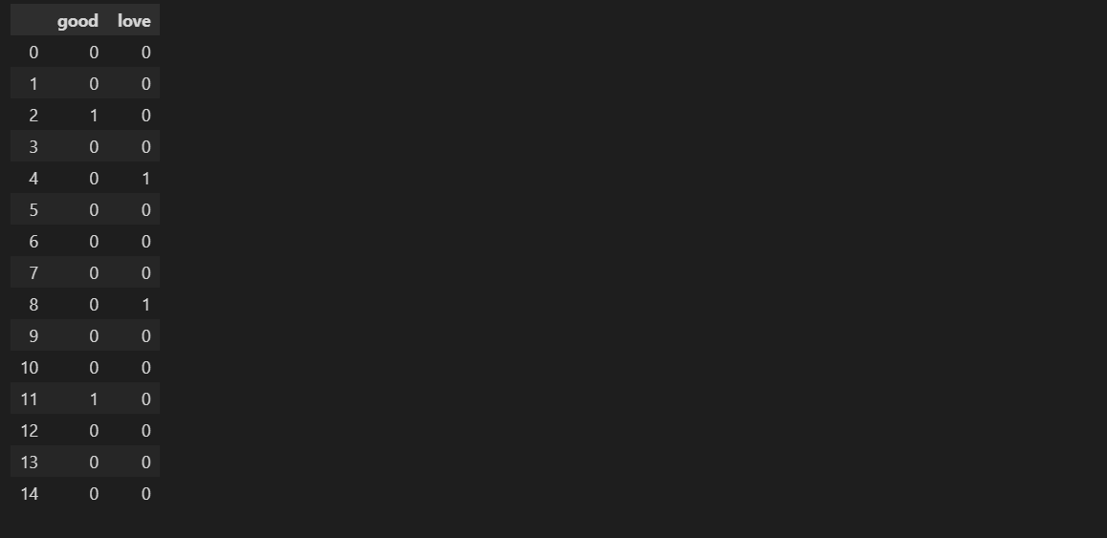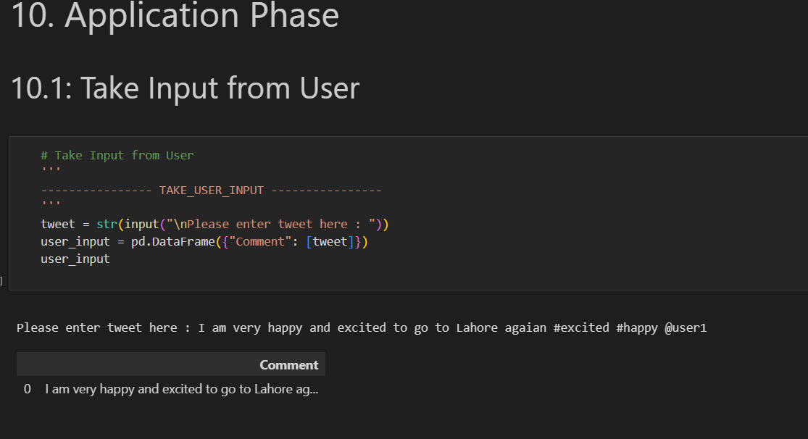

GUI:

